Name : Muhammad Abubakar Siddique
Roll No : SU92-BSAIM-F24-138
Class : BSAI-3C
Subject : AI
Task No : 01
Question No 1 : Dynamic Calculator
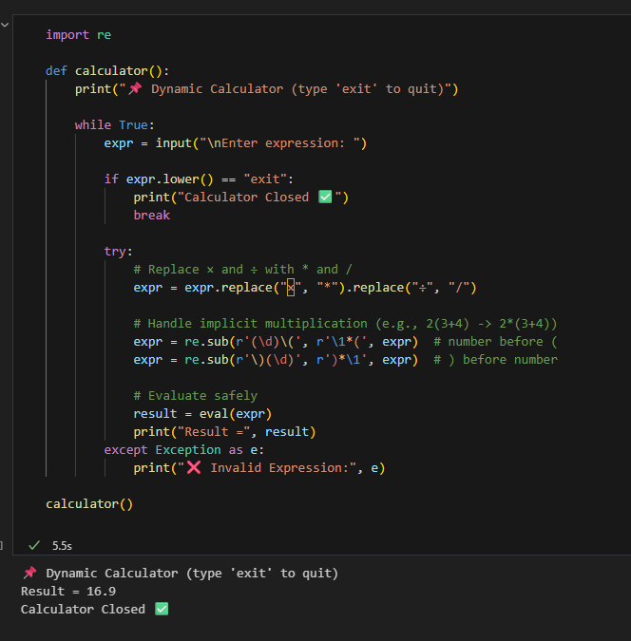

This program is a simple dynamic calculator built in Python. When you run it, the calculator keeps asking for a math expression until you type "exit" to close it. First, it replaces special math symbols like × and ÷ with Python’s operators * and /. It also fixes hidden multiplication cases such as 2(3+4) by automatically inserting a *, turning it into 2*(3+4). Once the expression is cleaned, the program uses Python’s eval() function to calculate the result and display it. If you type something wrong, it will show an “Invalid Expression” message instead of crashing. Overall, this program works like a normal calculator but is smart enough to handle both standard and implicit mathematical expressions.

